Let me toss this out to you as a suggestion for both an exit and to reduce the whip, and this is only for the GBP/JPY trade. I know it is changing the crossover system some, but I think it may help

You want to do 2 things. Maximize profit and reduce loss

Put a 125 pip channel surrounding your 100sma. The channel’s primary purpose is to act as a stop loss/take profit

A valid entry signal can only occur when the price starts above/below the channel (even 1 pip above/below) immediately prior to a cross. Enter with 2 lots in the direction of the cross. Set your stop loss equal to the one side of the channel and the take profit on 1 lot equal to the other side of the channel. The second lot will be allowed to run until the 9sma crosses through the outer boundary of your channel and back again or will be closed on the next valid opposite signal. By using the channel to exit the 2nd lot, you will get out of a trade much sooner, saving you some pips.

Look at the attached pictures.
9SMA – Yellow
100SMA – Red
Channel - Blue

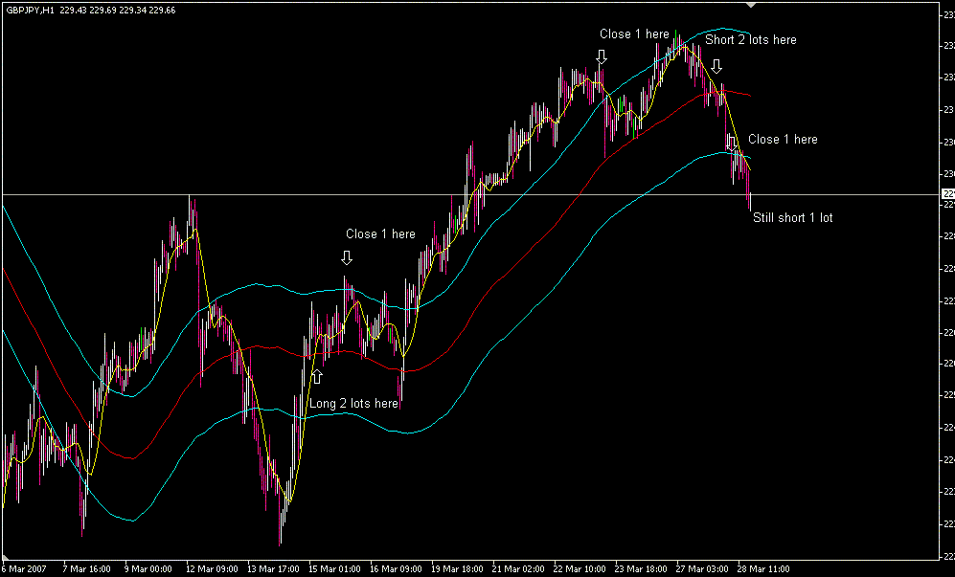

The first one is of the recent run in GBP/JPY. This is maximizing profit

Trade one is set up by price outside of the channel on 3/14
Order is placed at cross of the 100SMA on 3/15
1st lot is closed later that day on cross of channel at t/p level
If the 9sma would’ve crossed back over the 100 SMA on 3/19 you would’ve had a valid short, but price changed direction and the 9sma crossed the channel later that day.
You now let the trade run until the 9 sma crosses back over the channel, which is when you close the 2nd lot

2nd trade was setup yesterday. The first lot hit t/p and the second lot is allowed to run.

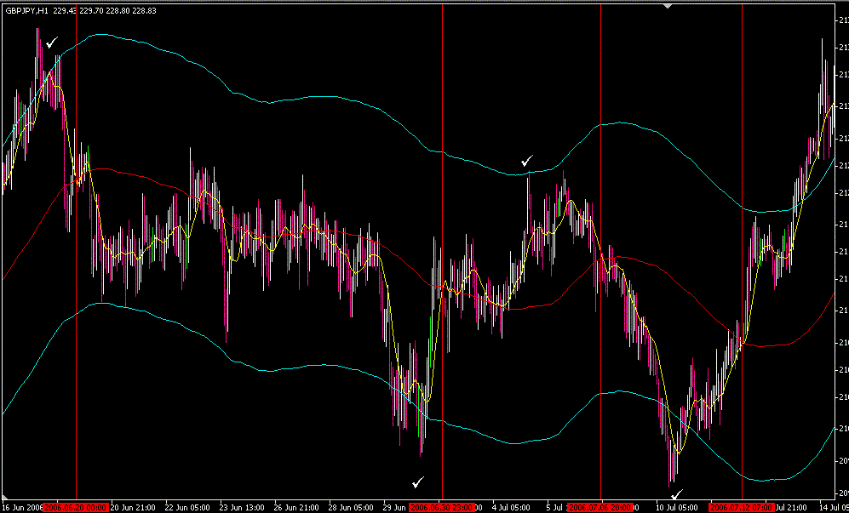

Second one is from the June chop. This is reducing loss

In this picture, I used checkmarks to show when there was a valid setup ( the price crossed one side of a channel), and the red vertical lines show valid orders.
If you just traded the cross of the 100sma, you would’ve been in 15 or 16 trades during this timeframe.
In each of these trades, you will make entry in the direction of the cross after the valid setup (checkmark). On the first 2 trades, the 1st lot goes to t/p but the 9 sma doesn’t cross the channel. On these trades, the 2nd lot will be closed when the reverse trade is made (the next red line) (often for a small loss or close to breakeven)
On the 3rd trade, the 9sma breaks the channel for a short period and then recrosses giving you your signal to close the 2nd lot. The fourth trade would’ve been allowed to run.
In all of these trades, by looking for a valid entry and having a stop loss in place rather than just using the cross, you end up with a small profit rather than being whipped to death

